//Programmer Name: Sharvil Prabhudesai 20co41

//Program title : Round Robin

#include<stdio.h>

int main()

{ int i,t=0,bt[10],wt[10],tt[10],rem_bt[10],n,ts,p[10];

int c;

float awt=0,att=0;

printf("Round Robin\n\n");

printf("enter the number of processes :");

scanf("%d",&n);

printf("enter the burst time for %d process \n",n);

for(i=1;i<=n;i++){

p[i]=i;

scanf("%d",&bt[i]);

rem_bt[i]=bt[i];

}

printf("\n enter the time slice:");

scanf("%d",&ts);

while(1) {

c=1;

for(i=1;i<=n;i++){

if(rem_bt[i]>0){

c=0;

if(rem_bt[i]>ts){

t=t+ts;

rem_bt[i]=rem_bt[i]-ts;

}

else{

t=t+rem_bt[i];

rem_bt[i]=0;

wt[i]=t-bt[i];

}

}

}

if(c==1)

break;

}

for(i=1;i<=n;i++){

tt[i]=wt[i]+bt[i];

awt=awt+wt[i];

att=att+tt[i];

}

printf("_________________________________________________________\n");

printf("| Process | Burst Time | Waiting Time | Turnaround time |\n");

printf("_________________________________________________________\n");

for(i=1 ; i<=n ; i++){

printf("| %d\t |%3d\t\t | %3d\t\t | %3d\t\t | \n",p[i],bt[i],wt[i],tt[i]);

}

printf("_________________________________________________________");

printf("\naverage waiting time: %f \n average turn around time:%f",(awt/n),(att/n));

return 0;

}

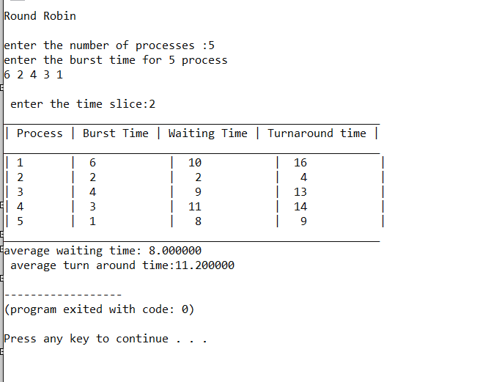

//Programmer Name: Sharvil Prabhudesai 20co41

//Program title : Shortst remaining time first

#include<stdio.h>

int main()

{ int i,t=0,bt[20],wt[20],tt[20],rem_bt[20],n,p[20],at[20],ft=0,small;

int count=0;

float awt=0,att=0;

printf("Shortst remaining time first\n\n");

printf("enter the number of processes :");

scanf("%d",&n);

printf("enter the burst time and arrival time for %d process \n",n);

for(i=1;i<=n;i++){

p[i]=i;

printf("enter the burst time for process for process %d : ",i);

scanf("%d",&bt[i]);

printf("enter the arrival time for process for process %d :",i);

scanf("%d",&at[i]);

rem_bt[i]=bt[i];

}

rem_bt[9]=999;

for(t=0;count!=n;t++){

small=9;

for(i=1;i<=n;i++){

if(at[i]<=t && rem_bt[i]<rem_bt[small] && rem_bt[i]>0 ){

small=i;

}

}

rem_bt[small]--;

if(rem_bt[small]==0){

count++;

ft=t+1;

wt[small]=ft-bt[small]-at[small];

awt=awt+wt[small];

tt[small]=wt[small]+bt[small];

att=att+tt[small];

}

}

printf("_________________________________________________________\n");

printf("| Process | Burst Time | Waiting Time | Turnaround time |\n");

printf("_________________________________________________________\n");

for(i=1 ; i<=n ; i++)

{

printf("| %d\t |%3d\t\t | %3d\t\t | %3d\t\t | \n",p[i],bt[i],wt[i],tt[i]);

}

printf("_________________________________________________________");

printf("\naverage waiting time: %f \n average turn around time:%f",(awt/n),(att/n));

return 0;

}

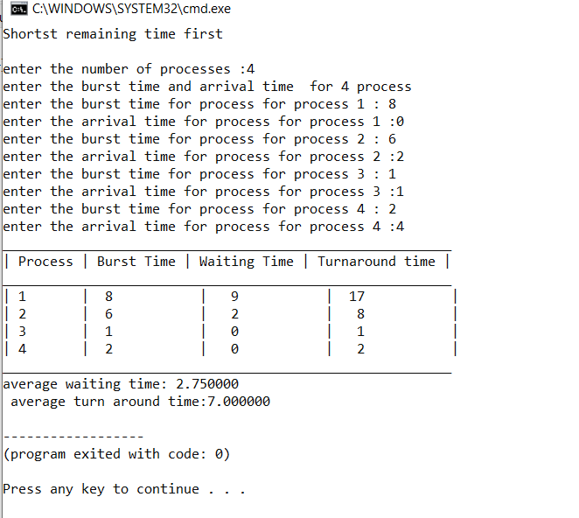

//Programmer Name: Sharvil Prabhudesai 20co41

//Program title : Premptive Priority

#include<stdio.h>

int main()

{

printf("Preemptive Priority\n\n");

int i,t=0,bt[20],wt[20],tt[20],priority[20],rem_bt[20],n,p[20],at[20],ft=0,small;

int count=0;

float awt=0,att=0;

printf("enter the number of processes :");

scanf("%d",&n);

printf("enter the burst time and arrival time for %d process \n",n);

for(i=1;i<=n;i++){

p[i]=i;

printf("enter the burst time for process for process %d : ",i);

scanf("%d",&bt[i]);

printf("enter the arrival time for process for process %d :",i);

scanf("%d",&at[i]);

printf("enter the priority for process for process %d :",i);

scanf("%d",&priority[i]);

rem_bt[i]=bt[i];

}

rem_bt[9]=999;

priority[9]=999;

for(t=0;count!=n;t++){

small=9;

for(i=1;i<=n;i++){

if(at[i]<=t && rem_bt[i]<rem_bt[small] &&priority[i]<priority[small] && rem_bt[i]>0 ){

small=i;

}

}

rem_bt[small]--;

if(rem_bt[small]==0){

count++;

ft=t+1;

wt[small]=ft-bt[small]-at[small];

awt=awt+wt[small];

tt[small]=wt[small]+bt[small];

att=att+tt[small];

}

}

printf("___________________________________________________________________\n");

printf("| Process | Burst Time | Priority | Waiting Time | Turnaround time |\n");

printf("___________________________________________________________________\n");

for(i=1 ; i<=n ; i++){

printf("| %d\t |%3d\t\t |%3d\t\t | %3d\t\t | %3d\t\t | \n",p[i],bt[i],priority[i],wt[i],tt[i]);

}

printf("___________________________________________________________________");

printf("\nAverage waiting time: %f \nAverage turn around time:%f",(awt/n),(att/n));

return 0;

}

